**Hello I AM FRESHER  
D.PREMA**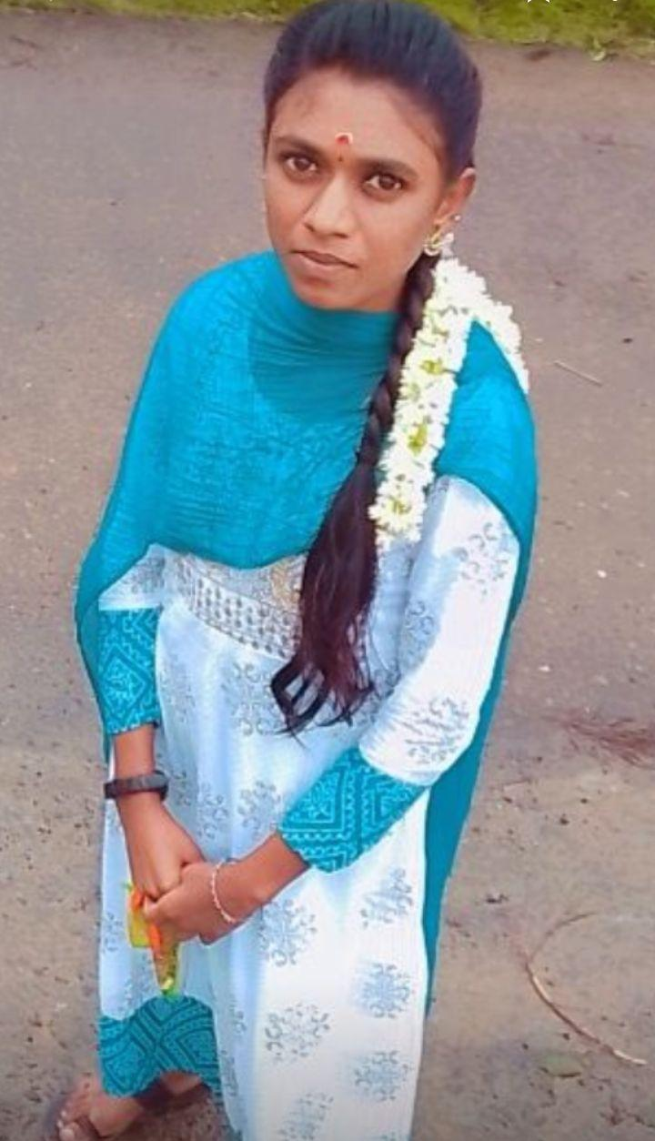

**premabsccs2401@gmail.com**

**9042150450**

**Date of Birth 24/01/2004**

**Gender female**

**Nationality Indian**

**Marital Status Single**

**Languages Known Tamil, English**

# **SUMMARY**

Fresher with a degree in from Government Arts and Science College Gudalur, flexible, motivated

organized individual with leadership qualities seeking Opportunity to grow consistently

with commitment and dedication towards my work and company.

# **HOBBIES**

Listening to music

# **Education**

Bsc.Computer science

Government Arts and Science

College Gudalur , Bharathiar University

# **SKILLS**

C

C++

# **DECLARATION**

I here by declare that the above mentioned information is correct upto my knowledge